WastewaterSCAN Program
VSD is partnered with the Stanford-based initiative WastewaterSCAN to monitor wastewater for Pathogens in the community to help guide public health responses. For more information on WastewaterSCAN visit: https://wastewaterscan.org/
VSD submit grab samples from the wastewater treatment plant primary sludge for pathogenic analysis. Graphs and data presented below can be obtained from here.
- SARS-CoV-2: a member of a large family of viruses called coronaviruses. The virus was first known to infect people in 2019 and is also called severe acute respiratory syndrome. The virus is thought to spread from person to person through droplets released in coughs, sneezes, or talking.
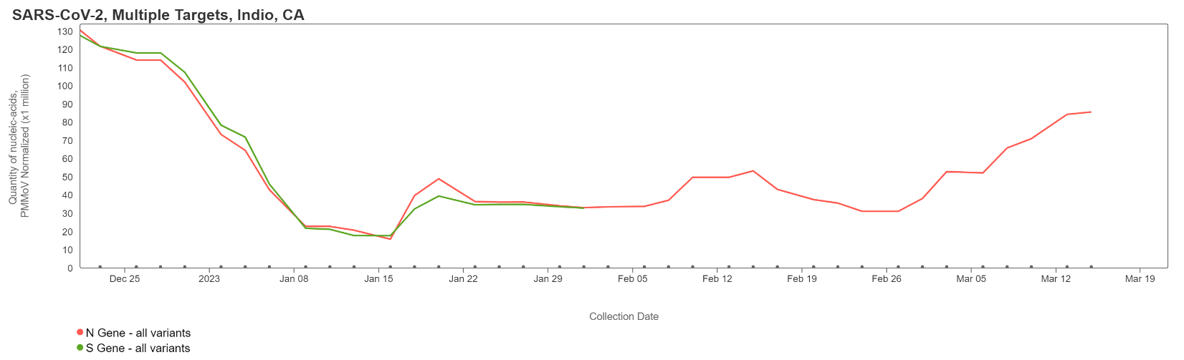
- mpox: is a rare disease caused by infection with the virus and is part of the family of viruses that cause smallpox. Monkeypox was discovered in 1958 with the first human case recorded in 1970. Mpox symptoms are like smallpox but milder and rarely fatal. Mpox is not related to chickenpox.
Positive samples were found in samples collected 09/14 – 09/21/22; all current samples are negative for the Mpx virus
- Influenza A: a seasonal respiratory virus and is the only influenza virus known to cause flu pandemics. Influenza A is usually more common and more severe than Influenza B.
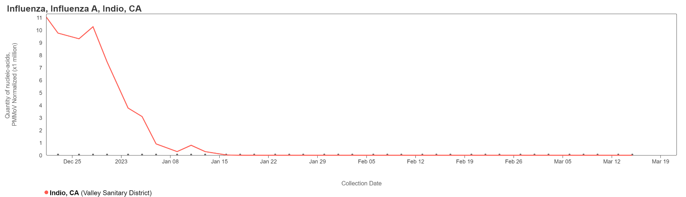

- Influenza B: a seasonal respiratory virus, along with Influenza A, is the cause of influenza outbreaks. Influenza B mutates more slowly, but was more common in the 2019-2020 flu season, particularly among young children. You can read more about it here and here.
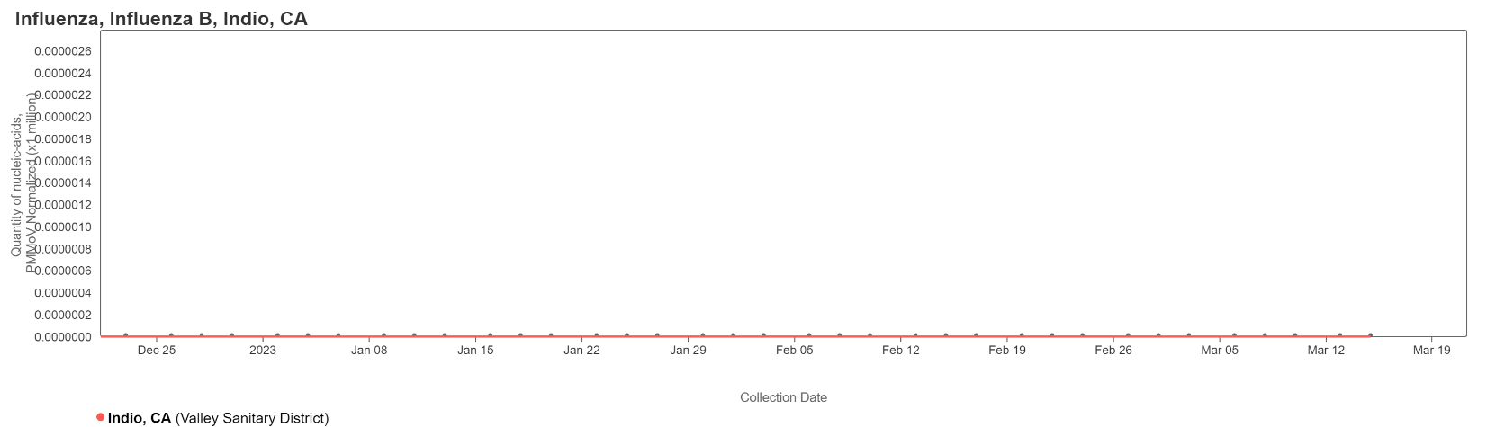

- Respiratory Syncytial Virus (RSV): is a common respiratory virus that usually causes mild, cold-like symptoms. RSV can be serious for infants and older adults. The most common cause of bronchiolitis (inflammation of the small airways in the lung) and pneumonia (infection of the lungs).
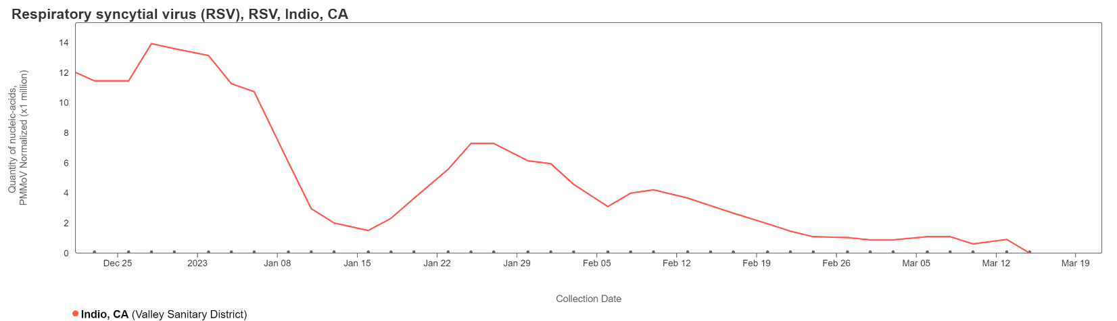
- Human Metapneumovirus (hMPV): a seasonal respiratory virus that is related to RSV. You can read more about infections caused by this virus here.
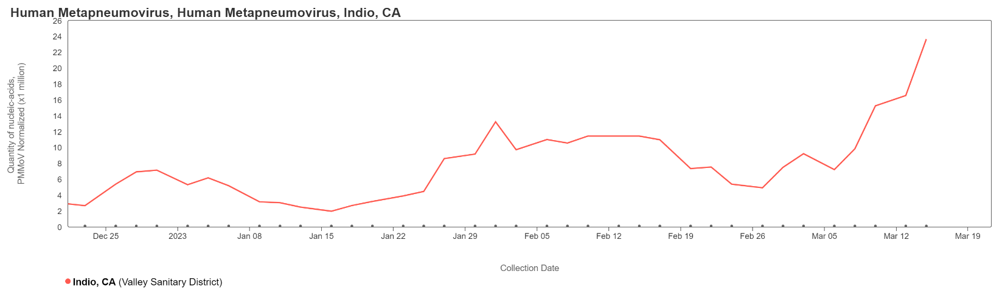

- Norovirus: a leading cause of gastrointestinal illness around the world. It has been measured in wastewater for years, the assay used will detect Norovirus GII.
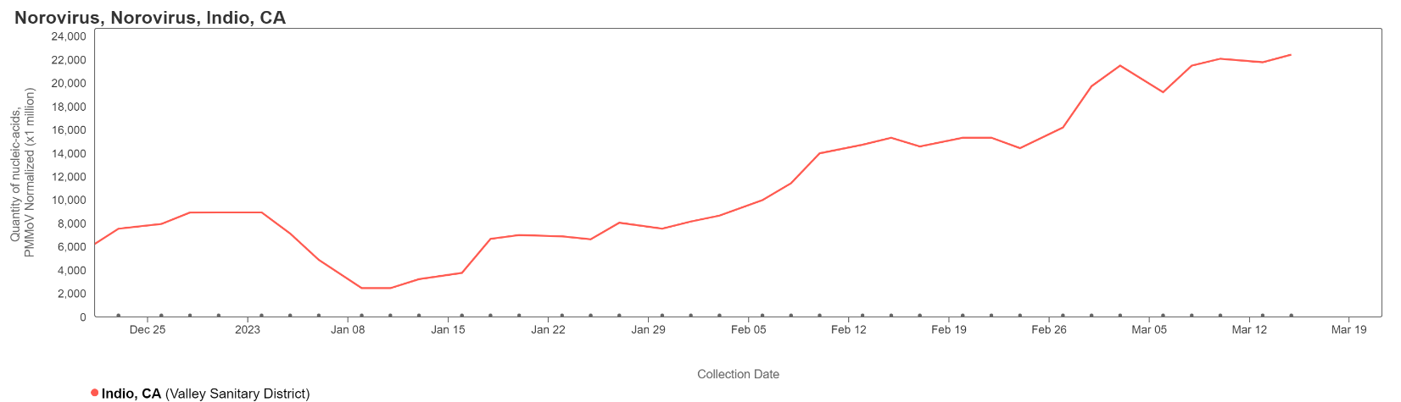
CDC – National Wastewater Surveillance Survey (NWSS) Program
VSD staff collect a 24-hour composite sample from the wastewater treatment plant influent (raw wastewater). For more information on CDC-NWSS visit: https://covid.cdc.gov/covid-data-tracker/#wastewater-surveillance
Results account for daily influent flow and population data.
- Rolling 10-sample chart: Reflects the latest 10 samples collected.

- Monthly Averages: Monthly average of Covid-19 results. Current month is based upon current data.

By Region
Nationwide:
Current wastewater concentration is 460 c/mL.
This is a change of -66 c/mL (13% lower).
This is 39% lower compared to the Delta peak (758 c/mL).
This is 9.9x lower compared to the Omicron peak (4533 c/mL).
Midwest:
Current wastewater concentration is 592 c/mL.
This is a change of -55 c/mL (8% lower).
This is 2% higher compared to the Delta peak (583 c/mL).
This is 6.2x lower compared to the Omicron peak (3692 c/mL).
West:
Current wastewater concentration is 466 c/mL.
This is a change of -24 c/mL (5% lower).
This is 10% lower compared to the Delta peak (517 c/mL).
This is 6.3x lower compared to the Omicron peak (2931 c/mL).
Northeast:
Current wastewater concentration is 465 c/mL.
This is a change of -95 c/mL (17% lower).
This is 22% lower compared to the Delta peak (598 c/mL).
This is 16x lower compared to the Omicron peak (7321 c/mL).
South:
Current wastewater concentration is 395 c/mL.
This is a change of -76 c/mL (16% lower).
This is 3.1x lower compared to the Delta peak (1222 c/mL).
This is 8.3x lower compared to the Omicron peak (3274 c/mL).

